Module 12
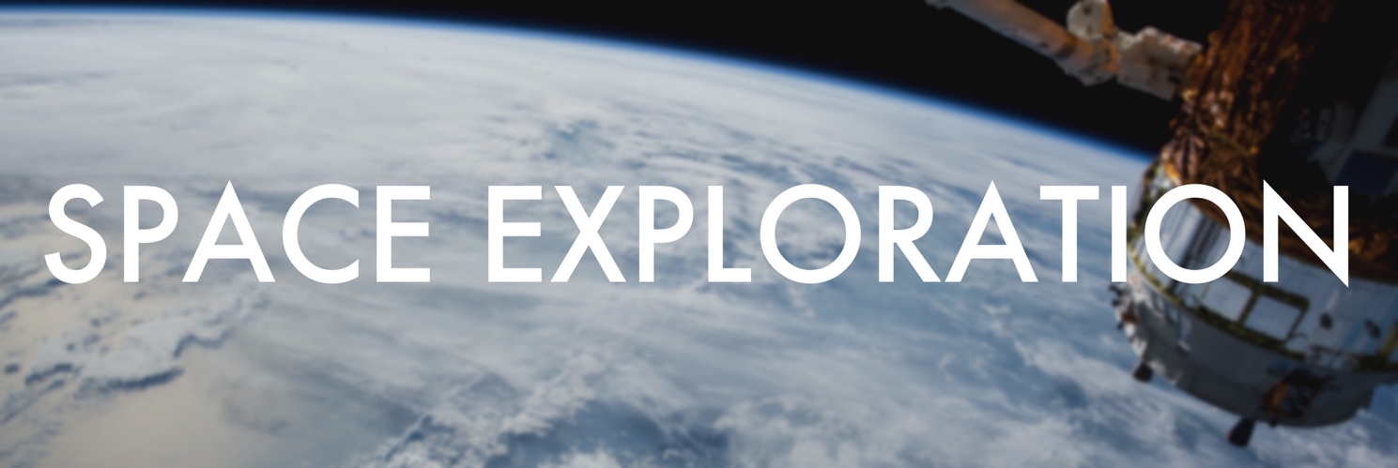
“Imagination will take you everywhere” – Albert Einstein

Lesson 1

Ex.1 - Guess the words in the picture:
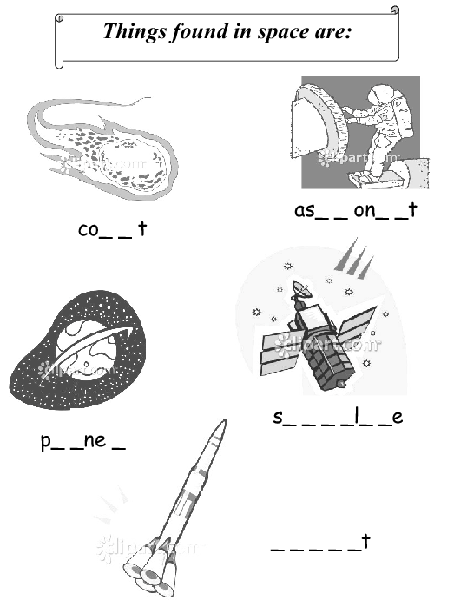

Check your answers: planet, comet, satellite, rocket, astronaut.

Grammar
see Grammar Reference to the Module p.40-43
Ex. 2 - Watch the video -” Hunting Down the Subjunctive”- and discuss it
After watching answer the following questions:
- Is subjunctive mood considered to be a modern or an old form in English language?
- What is a subjunctive? (it is a verb form which expresses possible, unreal, imaginary or desirable situation)
- Where could subjunctives be found? (in conditionals, wishes and some other places)
- What is the first place where subjunctives could be found?
In the sentences which start with:
a. It is important that you go
b. It is essential that he see
c. It is crucial that they leave
d. It is best that you be
- What is the second place where subjunctives could be found?
(with the verbs like suggest, recommend) (I suggest that you be; I recommend that he not drink)

Ex.3 - Translate into Russian without a dictionary paying attention to the subjunctive mood:
- Scientists suggested that a device to measure radiation beyond the Earth’s protective magnetic field should be placed on an interplanetary spacecraft.
- Students are to put down this word into their notebooks lest they should forget it.
- Understanding how the human brain works could result in making computers capable of performing a certain amount of independent work.
- It is necessary that new materials should be created in the near future.
- It is desirable that more powerful internal combustion engines should combine high efficiency and light weight.
- It would have been impossible to launch space vehicles provided we had not had the necessary polymeric materials and synthetic fuels.
- It is essential that highly sensitive reception devices should be made for the radio telescope to achieve better results in observation.
- It is necessary that automatic stations should be launched before manned spaceships.
- Provided the laboratory continued this experiment it would take three years to complete it.
- It is desirable that special space robots be developed which could be sent to investigate remote areas without worrying about whether they would come back or not.
- It is necessary that a superconductor should be cooled to almost -273ºC.
- If every star in the sky shone with the same degree of brightness, the distance to any star could be readily calculated.
- It was suggested that radioisotopes should be used to measure the thickness of these metal objects.
- The experts insisted that the substance used for industrial purposes should be chemically pure.
- It is urgent that we debate the importance of such experiments.
- Make exact calculations lest you should fail with your experiment.

Speaking
Ex. 4 - Work in small groups of two or three. Ask your group-mates what would happen if…, then give your own answer:

e.g. - What would you do if you met an alien?
- If I met an alien I would ask him/her about the most advanced technologies they use.
- That’s right, but if I met an alien I would try to learn his language and would just talk with him/ her.
- If I were a scientist in rocketry…
- Had I an opportunity to design a…
- If the missions to Venus were possible…
- If I could grow potatoes on Mars…
- If the atmosphere on Mars wasn’t rarefied (разреженный)...
- If I were a crew member on the ISS…
- Had the governments invested to space research more…
- If people were able to colonize Mars…
- Had I spoken to Tsiolkovsky…
- Were a space lift built from the Earth to a geostationary orbit...
- What if Russia had never launched the Sputnik?
- What if no one had ever tried to break the sound barrier?
- What if you were offered an opportunity to ride on the Space Shuttle?

Watch the video “Space Exploration” and discuss the main ideas of it.
- where do we come from
- where are we going
- are we alone
- why Universe exists
- for survival
- for future
- the courage
- the belief
- we know we are not alone
- explore other civilizations in the vast Universe
- be fearless of the spatial (пространственный) - temporal limitation
- contemplate (рассматривать, обдумывать) the truth of the Universe and life

Ex. 5 Answer the questions:
- What comes into your mind when someone says “Space exploration“? (use appropriate adjectives)
- What are the greatest achievements in space exploration in your opinion?
- Can you remember the names of people who contributed greatly into space research?
- Do you believe that there is life on other planets? Do you think that humans will ever go and live on other planets?

Do you know the order of the planets in the Solar System? If not, the following mnemonic rule might help you to remember it: «My Very Educated Mother Just Served Us Nachos»

Ex. 6 - Correct the mistakes, if any, in the following sentences:
- The teacher recommended that we used another method of analysis.
- It was necessary that everybody was present.
- I suggest that he find some other job.
- The officer ordered that the soldier use the protective suit.
- It is important that he has everything he needs for the experiment.

Ex. 7 – Translate the sentences from Russian into English:
- Вы должны произвести точные (exact) расчеты, чтобы вы не провалили (to fail) свой эксперимент.
- Необходимо, чтобы все вещества были расплавлены, смешаны, охлаждены и возвращены на Землю.
- Если бы спутник Telstar был построен по технологиям прошлого десятилетия, то он выполнял бы совершенно другие задачи. (III Conditional)
- Желательно, чтобы вы обеспечили (to provide) нас необходимой информацией.
- Некоторые материалы охлаждаются почти до -273С, чтобы они стали сверхпроводниками.

Attention: Choose one of the suggested topics from the list below, carry out the research work and present it in the form of the project at your group mini-conference (week 15-16).

Student Research Projects
Students can deal with research projects at many different levels of sophistication, the following list presents only some potential research topics. They cover a wide range of topics; obviously, science is the focus, but there are also links to other subjects including family studies, nutrition, environmental studies and geography.
The list of topics has the potential to be endless. The list was developed using "the availability of resources" as one of the key criteria. It should be viewed simply as a starting point for ideas related to student research.

Suggested Topics:
- How does the climate of Mars compare to that of Earth?
- What technologies should be implemented to allow the growing crops on Mars?
- Review several space-related films and identify "errors" in how life in space is depicted.
- Is there microbial life in the surface layers of Mars?
- The Moon will play an important role in the future space travel. Research to find out what the plans are for the future Moon expeditions.
- How will travel to, and working on the Moon assist in the plans for space travel to Mars?
- Is there any true Paleobiological evidence of life on Mars?
- How can research related to farming on Mars be applied to practices here on Earth?
- What is the relationship between science fiction and space travel reality?
- Sputnik went up in 1957. Then, the United States became more active in the space program. What countries are now in the "space race" and what are their major areas of focus?
- You have an idea for space exploration. Research how you could find out if it is practical.
- Should human space travel be replaced with robots?
- Compare the exploration of space to the exploration of a new area in the history of the Earth - the Americas, Africa, or the expedition to the top of Mount Everest.
- Should the exploration of space be controlled/financed by countries or should the process be privatized?
- Research Newton's laws of motion and design a demonstration of Newton's first or third law. The demonstration must be applicable to space travel. A possible extension might involve students' study of the relationships among force, mass and acceleration [Newton's 2nd law] and the design of an experiment to test the variables.
- Although many young people would like to be astronauts, it is statistically more difficult than becoming a major league athlete. However, there are many alternative occupations related to the space program that will demand scientific and technological expertise. Research one area of interest related to space and/or space agriculture, and outline the educational path it would take to work in this area.
- On Earth we may have to deal with sunburn as a consequence of working outdoors in summer. Research the effect of radiation on astronauts and, in particular, on astronauts who may be spacewalking during the construction of the International Space Station.
- Research the effect of radiation on the development of plant life for space travel.
- Research one of the following aspects of life support in space - food, water, waste disposal, atmosphere control, or fire protection.
- Is it possible to use solar rays in space to make a space "sailing ship" move through space, thus creating an energy efficient space craft?
- Research the earth's magnetosphere - how it works, its components, the benefits for us on earth, how it is detected from a spacecraft.
- Research how food will be produced within closed life-support systems as a means of enhancing self-sufficiency and crew health during long space missions.
- Tomatoes are the focus for this study; research to determine the role of other potential food sources that have been studied for long-term space travel. Outline the advantages and disadvantages of each. Rank order a list of potential foods for long-term space travels.
- Research the topic of "space medicine".
- Design a habitat for living on Mars for 6 astronauts for a period of six months; the habitat would include bedrooms, bathrooms, exercise area, kitchen, laboratory and medical station.
- Design a kitchen appliance that could be used on the surface of Mars.
- Research the nutrition issues facing astronauts when travelling to and from Mars.
- Design a greenhouse for implementation on the surface of Mars. Consider Mars' weather conditions – temperature level and moisture availability, chemistry, radiation and gravity.
- Investigate the climate and physiography of Devon Island to determine the rationale for choosing this site for the CSA Mars simulation studies.
- Research the time-line from now until a trip to Mars takes place. Identify one major obstacle to overcome in the time-line and suggest solutions to eliminate the obstacle.
- Research areas of the Earth that might be used for simulations of the Mars environment. Prioritize your choices and provide a rationale for the ranking.
- Identify an environmental problem on Earth that may be solved by the application of space-based research on Earth; correlate the potential findings from space to the Earth-based environmental problem.

